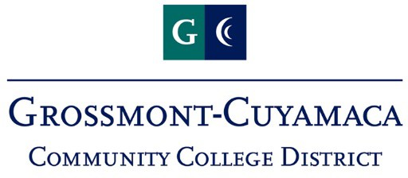

Technology Planning & Policy Council (TPPC)
Agenda
April 19, 2023
Zoom: https://us06web.zoom.us/j/81784976652

Members
- Kerry Kilber Rebman,  Associate Vice Chancellor, Technology, (Chair) | - Pam Wright, Director, Enterprise Systems**
- Barbara Gallego , Associate Vice Chancellor,  Educational Support Services | - Jerry Williamson, Director, Computer Services**
- Marshall Fulbright, Vice President, Academic Affairs, Grossmont College* | - Steve Abat, Director, Technical Services**
- Alicia Munoz, Vice President, Instruction, Cuyamaca College* | - Nicholas Gekakis, Faculty Representative, Technology Committee, Grossmont College
- TBD, Vice President, Administrative Services, Grossmont College* | - Bri Brown, Faculty Representative, College Technology Committee, Cuyamaca College,
- Nicole Salgado, Vice President, Administrative Services, Cuyamaca College* | - TBD, Classified Staff Representative, Technology Committee, Grossmont College
- Marsha Gable, Vice President, Student Services, Grossmont College | - Amber Toland Perry, Classified Staff Representative, College Technology Committee, Cuyamaca College
- Bri Hays, Vice President, Student Services, Cuyamaca College | - Robert Mountain, Classified Staff Representative, District IT
- Tate Hurvitz, Dean, Learning & Technology Resources, Grossmont College | - Sienna Shaba, Student Representative
- Jessica Hurtado Soto, Learning & Technology Resources, Cuyamaca College | - Leif Christiansen, Research & Planning Representative
 | - Recorder, TBD
 | Resource Personnel
 | - President, Grossmont College; President, Cuyamaca College;; Information Technology Staff; and other representatives as required

* The Vice Presidents will alternate both campus and role. (Ex: Vice President, Administrative Services, Cuyamaca College will serve concurrent with Vice President, Academic Affairs, Grossmont College)
** The IT Directors will alternate as needed

- Welcome
- Review & Approve Minutes
- Additions/Deletions to Agenda
- AP 3720 Update
- BP 6335 Review
- Plan for CyberSecurity Funding from the State
- Tech Request & Prioritization Processes
- Tech Plan
- Other Business
- Next Meeting | March 15, 2023

